

***Project Report***

# On

“Quiz Application in Java"

***Project Report***

# On

Quiz Application in Java

**Submitted To:**

**MD. Mahbub-Or-Rashid**

Assistant Professor

Department of CSE, BUBT

**Submitted By:**

**Group: 9**

|  |  |  |
| --- | --- | --- |
| **Name** | **ID** | **Intake/Section** |
| MD. Ashikur Rahman | 21225103**471** | 49/06 |
| Abdullah Al Mahmud Joy | 21225103**506** | 49/06 |
| Kaspia Alam | 21225103**487** | 49/06 |
| Mirza Niaz Morshed | 21225103**467** | 49/06 |
| Ayesha Siddika Esha | 21225103**495** | 46/06 |

**ACKNOWLEDGEMENT**

We express our gratitude and sincere thanks to our teacher **MD. Mahbub-Or-Rashid** Department of **CSE** for his gracious efforts and keen pursuit, which have remained a valuable asset to the success of our project report. His dynamism and diligent enthusiasm have been highly instrumental in keeping our spirits high. His flawless and forthright suggestions blended with an innate intelligent application have crowned our task with the success. We truly appreciate and value his esteemed guidance and encouragement from the beginning to the end of this Project. We are indebted to him for having helped us shape the problem and providing insights into the solution

At last, we are highly thankful to the Almighty, who has given us the courage and wisdom throughout this whole journey.

**ABSTRACT**

In this paper we are developing a Quiz Application in Java that aims to provide users both teachers and students with an interactive platform to participate in quizzes on various topics. The application will be designed to offer a user friendly experience while efficiently managing questions, answers, and scoring all while managing a secure database to store our data and results in a user friendly interface.

***(*Please Turn Over)**

## 

## Table of Contents

|  |  |  |
| --- | --- | --- |
| **Chapter** | **Content** | **Page** |
| **1** | Introduction | 6 |
| **2** | Background, Motivation, and Objectives | 7-8 |
| **3** | Proposed method | 9-10 |
| **4** | Methodology and simulations | 11-22 |
| **5** | Results and Discussions | 23 |
| **6** | Conclusion | 24 |

## Chapter 1

### 1.1 Introduction

The purpose of this project is to create an accessible and enjoyable Java Quiz Application to enhance learning experiences. Welcome to our Java Quiz Application project, aimed at creating an engaging learning experience for educators, students, and quiz enthusiasts. Our objective is to develop a user-friendly app covering diverse subjects, incorporating an interactive feature that allows real-time participation and score comparison.

Leveraging the capabilities of Java, we are integrating a secure database to efficiently manage quiz content, ensuring scalability for future enhancements. The application's design prioritizes simplicity for easy navigation and inclusivity, accommodating users of all abilities. Multimedia elements, including images, audio, and video, enhance the overall learning journey.

User engagement is central to our project, with instant feedback and a motivational scoring system to encourage continuous improvement. Rigorous testing is conducted across various devices to address potential issues, and user feedback is actively sought for ongoing refinement.

This project represents the convergence of Java's power with interactive quizzes, facilitating an enjoyable and seamless learning experience.

## Chapter 2

### 2.1 Background

The Java Quiz Application project responds to the changing educational landscape, amplified by the challenges of the COVID-19 pandemic. With physical classrooms constrained due to safety measures, there is a heightened need for an online, interactive learning tool. The limitations imposed by the pandemic underscore the importance of virtual solutions, where a dynamic quiz platform becomes a valuable educational resource. This project aims to address the educational void created by COVID-19 restrictions, offering a versatile and accessible avenue for knowledge assessment and reinforcement.

### 2.2 Motivation

The motivation behind the Java Quiz Application project is rooted in the desire to transform adversity into opportunity. Faced with the constraints of the COVID-19 pandemic, where traditional classrooms are limited, there's an earnest need to foster engaging and accessible learning experiences. This project is driven by the belief that by harnessing the power of technology, specifically through a dynamic quiz platform, we can not only adapt to the current challenges but also create an innovative and enjoyable way for individuals to continue learning and testing their knowledge in a virtual environment.

### 2.3 Objectives

The primary objectives of the project are as follows:

**1.Create a User Interface:** Develop an intuitive user interface that allows users to access quizzes, answer questions, and view results.

**2.Question Management**: Implement a system to manage questions, including adding, editing, and deleting questions.

**3.Scoring System:** Design a scoring mechanism that calculates and displays users' scores based on their answers.

**4.Multiple Choice Questions:** Support multiple-choice questions with options and the ability to select a single correct answer. 5.User Authentication: Implement user authentication to ensure secure access and personalized user profiles.

**5.Timed Quizzes:** Provide an option to set time limits for quizzes, ensuring a challenging and engaging experience.

**6.Feedback:** Enable users to receive feedback on their answers, showing correct answers for incorrect responses.

**7.Admin Panel:** Develop an admin panel to manage quiz content

## Chapter 3

### 3. Proposed method

Our approach for developing the Java Quiz Application involves leveraging the **NetBeans Java IDE** for streamlined coding and project management. The application's data will be stored and managed using SQL for efficient database operations.

**Key Steps:**

**User Interface Design with JFrame:** Utilize the NetBeans IDE to create an intuitive and visually appealing user interface using JFrame. This includes designing screens for quizzes, user registration, login, and results.

**Database Setup using SQL**: Implement a robust database structure using SQL to store user information, quiz questions, and results. Establish connections between the Java application and the SQL database to facilitate seamless data retrieval and storage.

**User Authentication:** Develop a secure login system using Java authentication mechanisms to ensure user privacy and data integrity.

**Quiz Customization:** Allow course teacher to customize quizzes through the application's interface such as update question, add new question, delete question, view result of the students etc.

**Score Tracking and Analytics:** Develop a robust scoring and analytics system using Java to keep track of individual and group

performance over time. Provide detailed insights into quiz results and progress.

**Thorough Testing:** Conducting rigorous testing of the application using the NetBeans IDE and Java testing frameworks. Identify and address any bugs or issues to ensure the smooth functionality of the quiz app.

**Documentation:** Create comprehensive documentation using NetBeans, detailing the application's architecture, code structure, and usage instructions. This will serve as a guide for future development and troubleshooting.

**Used components:**

1. NetBeans

2. SQL Connector (JDBC)

3. JFrame (Java Swing)

4. Java-based authentication system

5. Custom Java code for quiz customization

6. Graphics and UI elements (such as photos)

## Chapter 4

### 4. Methodology:

**1. Index Class:**

- Purpose: Represents the main entry point of the application.

- Functionality: Displays the initial landing page with options for teachers and students to access different sections.



**2. Login Teacher Class:**

- Purpose: Allows teachers to log into the system using unique credentials.

- Functionality: Validates teacher login credentials and grants access to the admin dashboard upon successful authentication.



**3. Admin Home Class:**

- Purpose: Exclusive access for teachers to manage and customize quizzes.

- Functionality: Provides a secure space for teachers to add/delete questions, view student results, and navigate to other admin-specific functionalities.



**4. Add New Question Class:**

-Purpose: Allows teachers to add new questions to the question bank.

- Functionality: Provides a user interface for teachers to input and submit new quiz questions, ensuring seamless integration into the question database.

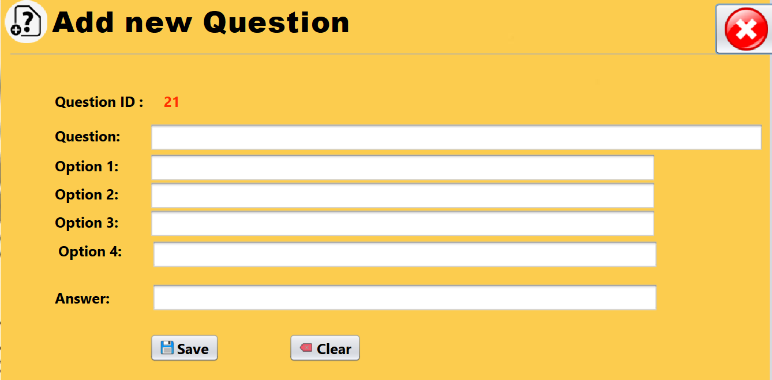

**5. Update Question Class:**

- Purpose: Permits teachers to modify existing questions in the question bank.

- Functionality: Offers a platform for teachers to select and edit questions.

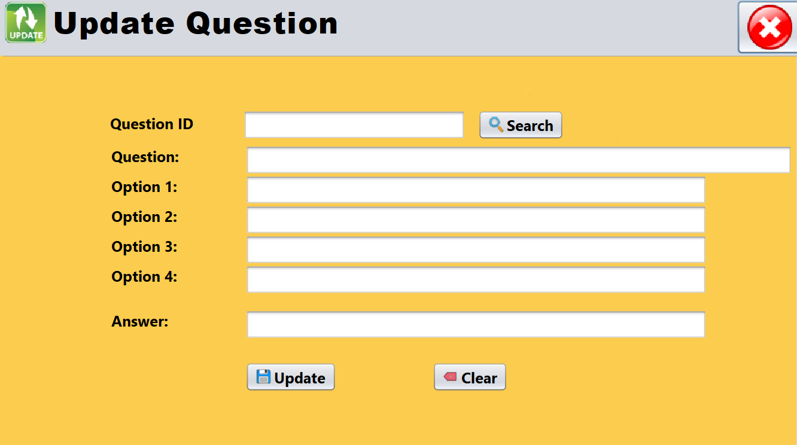

**6. Delete Question Class:**

- Purpose: Enables teachers to remove specific questions from the question bank.

- Functionality: Provides a mechanism for teachers to maintain and update the question database.

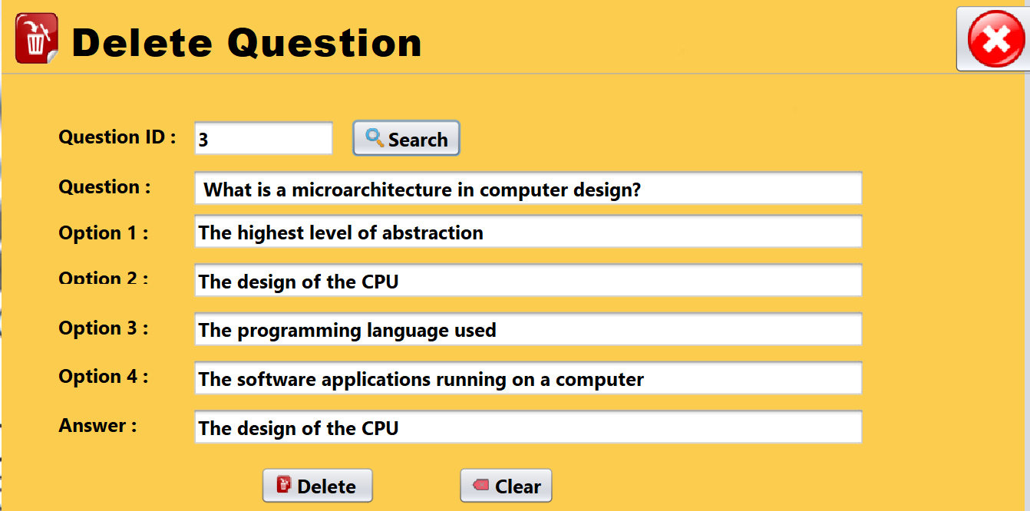

**7. All Question Class:**

- Purpose: Displays a list of all available questions in the database.

- Functionality: Allows teachers to view and manage the entire question bank for quiz customization.

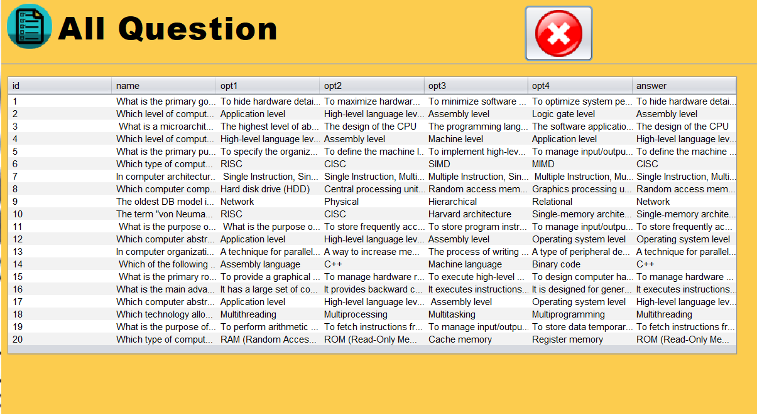

**8. All Student Result Class:**

- Purpose: Offers teachers an overview of all student results.

- Functionality: Presents a comprehensive list of student scores and performance metrics for analysis.

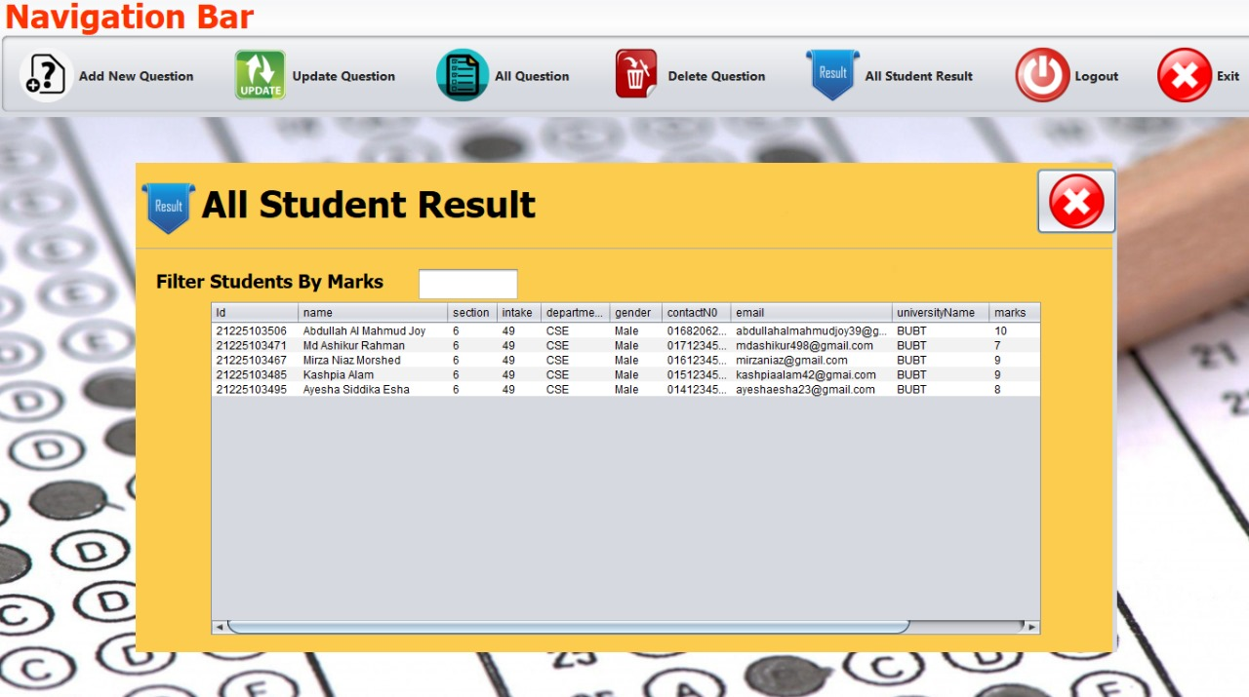

**9. Student Details Class:**

- Purpose: Collects necessary information from students before entering the quiz.

- Functionality: Prompts students to input required details, such as name and class, to personalize the quiz experience.

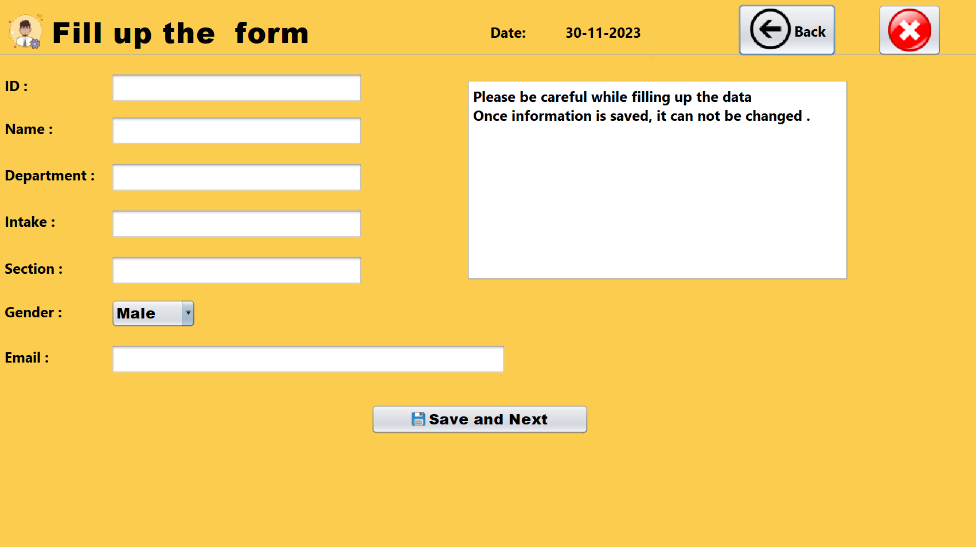

**10. Instructions Class:**

- Purpose: Provides guidance and instructions for students before starting the quiz.

- Functionality: Displays essential information, rules, and guidelines for students to follow during the quiz.

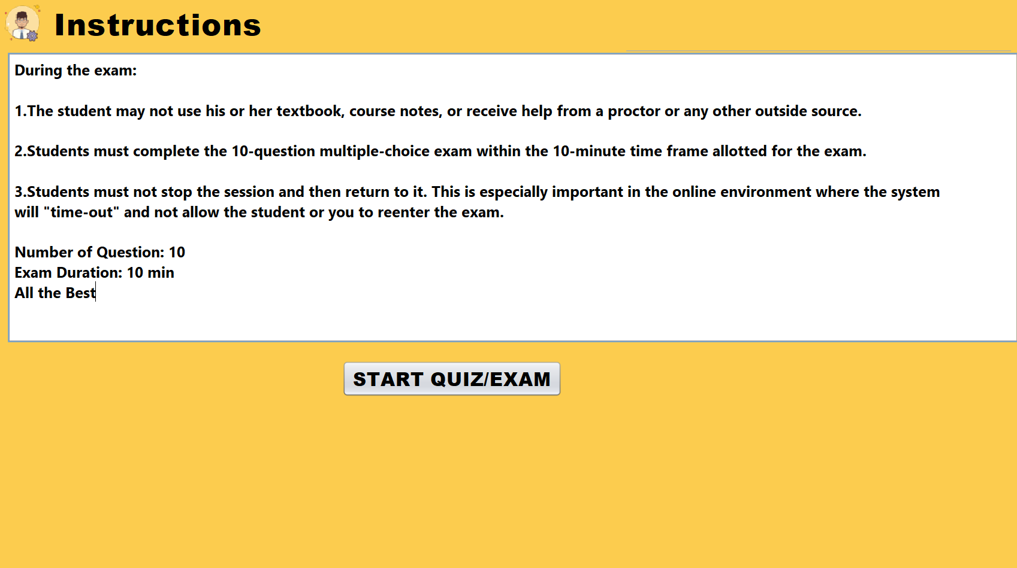

**11. Quiz Exam Student Class:**

- Purpose: Represents the main quiz interface for students.

- Functionality: Implements the quiz with multiple-choice questions, a time limit, and real-time score updates. Manages the entire quiz-taking process.

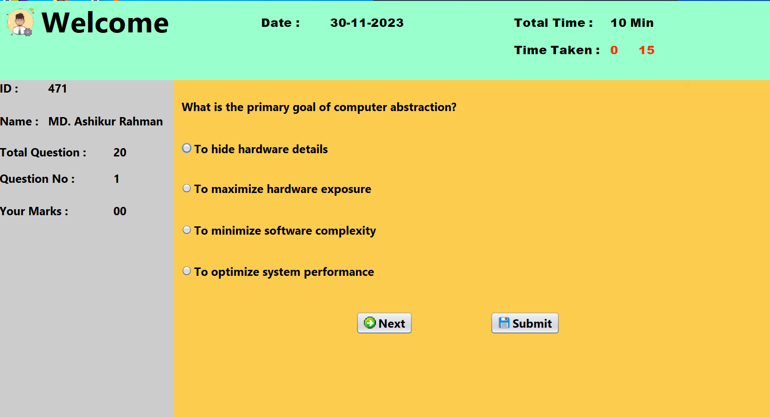

**12. Successfully Submitted Class:**

- Purpose: Indicates successful submission of the quiz by the student.

- Functionality: Displays a confirmation message upon successful completion of the quiz, acknowledging that the answers have been submitted.

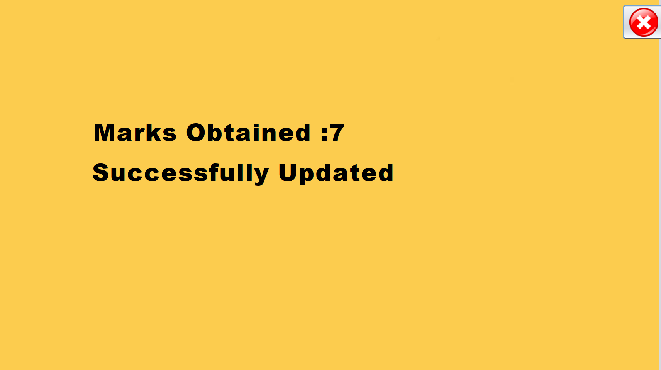

**13. Acknowledgement Class:**

- Purpose: Provides acknowledgment or confirmation messages for various actions. - Functionality: Displays messages to confirm successful actions, such as successful login, deletion of a question, or submission of a quiz.

Each class contributes to the overall functionality of the Java Quiz Application, facilitating smooth interactions for both teachers and students.

## Chapter 5

**5. Results and discussions**

**Questions in Database**

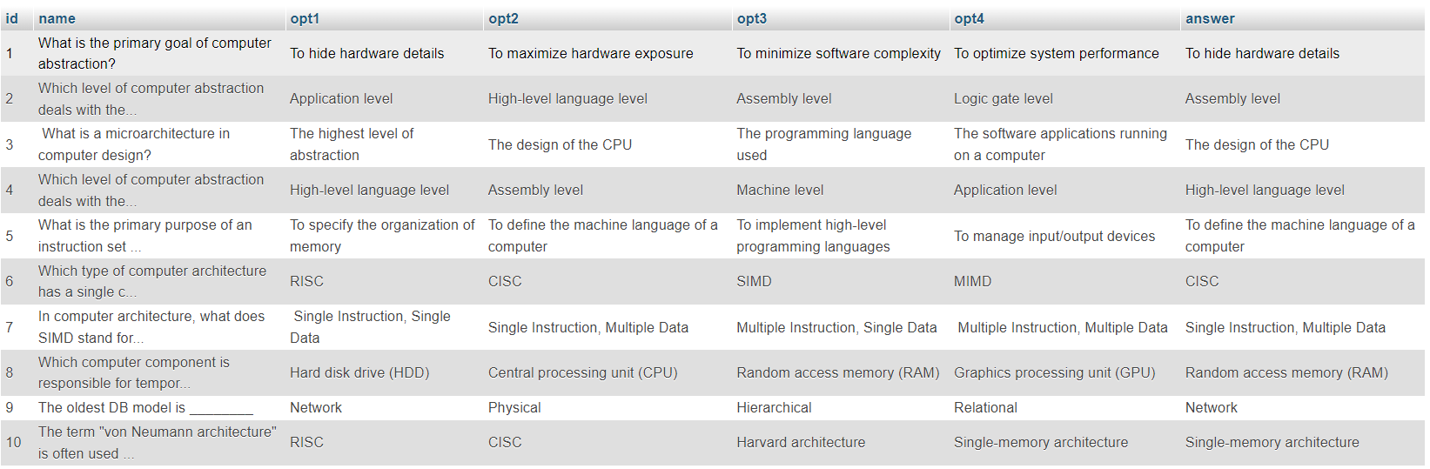

**Student details and results in Database:**

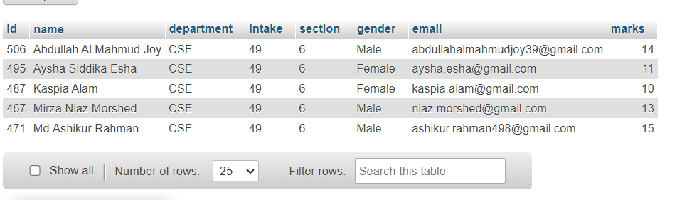

## Chapter 6

### 6. Conclusion

Our Java Quiz project is a success! We've built a smart and easy-to-use app that helps teachers and students, especially during the tough times of the COVID-19 pandemic. Using Java, SQL, and NetBeans, we created a friendly space for learning.

The different parts of the application, like Admin Home for teachers, QuizExam for students, and others, work together to make learning fun and personalized. We made sure teachers can easily manage quizzes, add new questions, and update existing ones.

This project proves that technology can make education better, even when things are changing. The app's design, features, and the teamwork behind it show how tech can bring learning to life.

Looking ahead, our Java Quiz application isn't just a tool for teachers and students—it's a step towards making education more interesting and accessible. This success is thanks to the teamwork and dedication of everyone involved in building this project.